

**‘Mindful Monday Club’**

**Club** (previously **Happy Monday Club**) will run from 3.30pm - 4.30pm all year-round and is suitable for children from **Year 1-6**. Places will be limited to 20 initially due to the age range of children in this group. Club is a safe space to chill out, have fun with friends and leave your worries behind. It’s a bit like a youth club. Miss Craigie will run the club with help from Mrs Markley and Miss Brittain.

At club we come together to think about our own *well-being* and explore why positive mental health contributes to our happiness. This is done through chats, exploring topics and activities such as friendship, developing teamwork/social skills, practising mindfulness and so on. It helps children to build confidence, self-esteem and develop resilience with the wide variety of activities on offer. Children can do things independently or with others? If you like making/doing things, arts and crafts are available each week. Maybe you enjoy playing board games, doing puzzles and taking part in games like table tennis/pool/table football? Perhaps you want to help others (we actively encourage kindness) or learn new skills/try new things? Whatever we can do, we will try, working together as a team! We will explore the five-ways to well-being through such activities which may be linked to a topic or theme, dependent on the time of the year. There is something for everyone! It would be lovely to see you there….

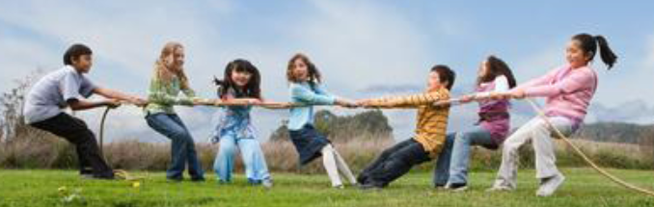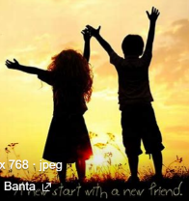

Make and Build Friendships

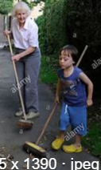

Be Active



Learn

New Skills

Be Mindful

***Give Back To Others***

**Places will be limited! Let us know if you’d like to come along and see what Mindful Mondays are about by 4th October!**

**My child** _________________________________would like to attend Mindful Monday Club from 4th November. ***By signing this they/you have made a commitment to attend unless they are absent from school or have a pre-arranged appointment after school hours.***

**Known Allergies** (we sometimes cook and have food!) _________________________________

**My child will be collected** each session by: __________________________________________(name/s)

**Signed:**_______________________________________(Parent/Carer/Guardian)

**Contact Number** (for emergencies and if school office is closed):__________________________________