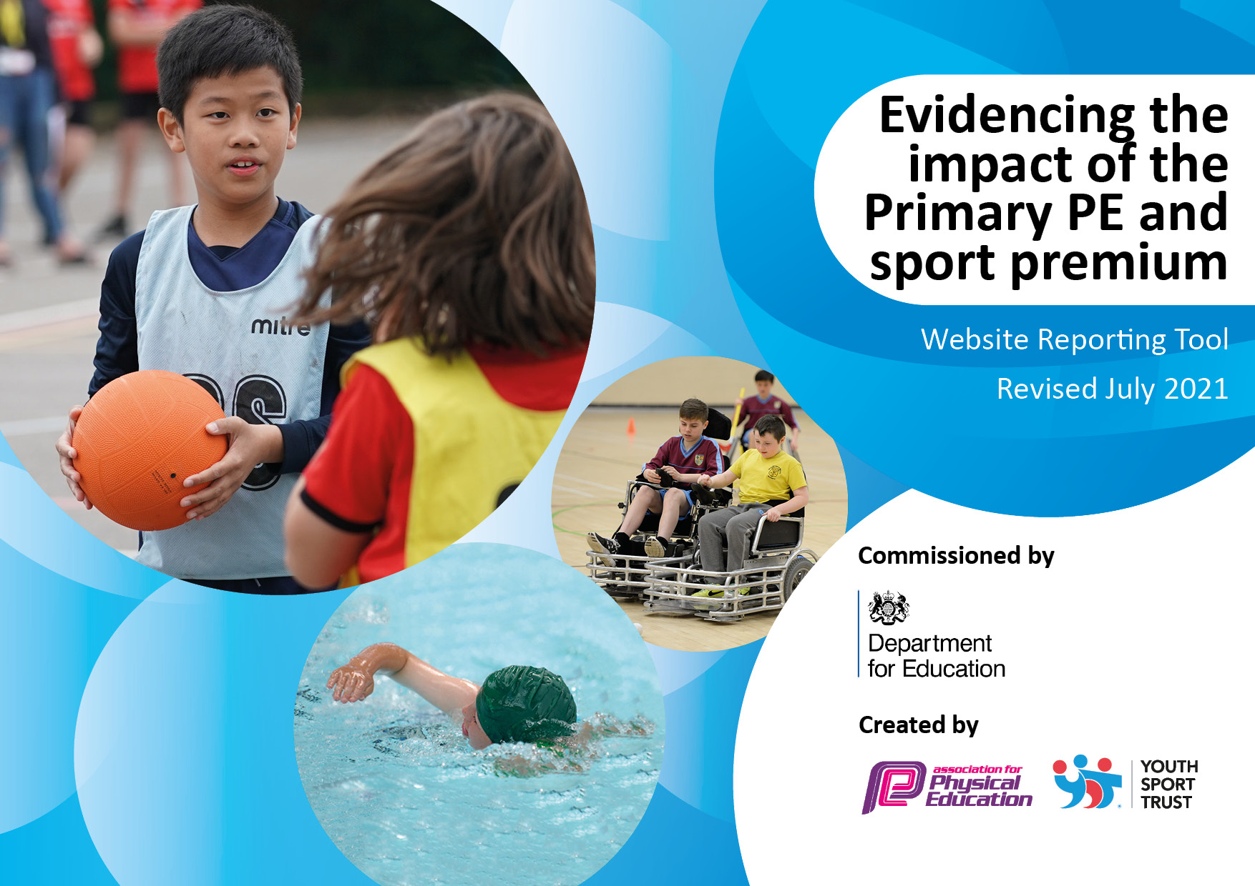
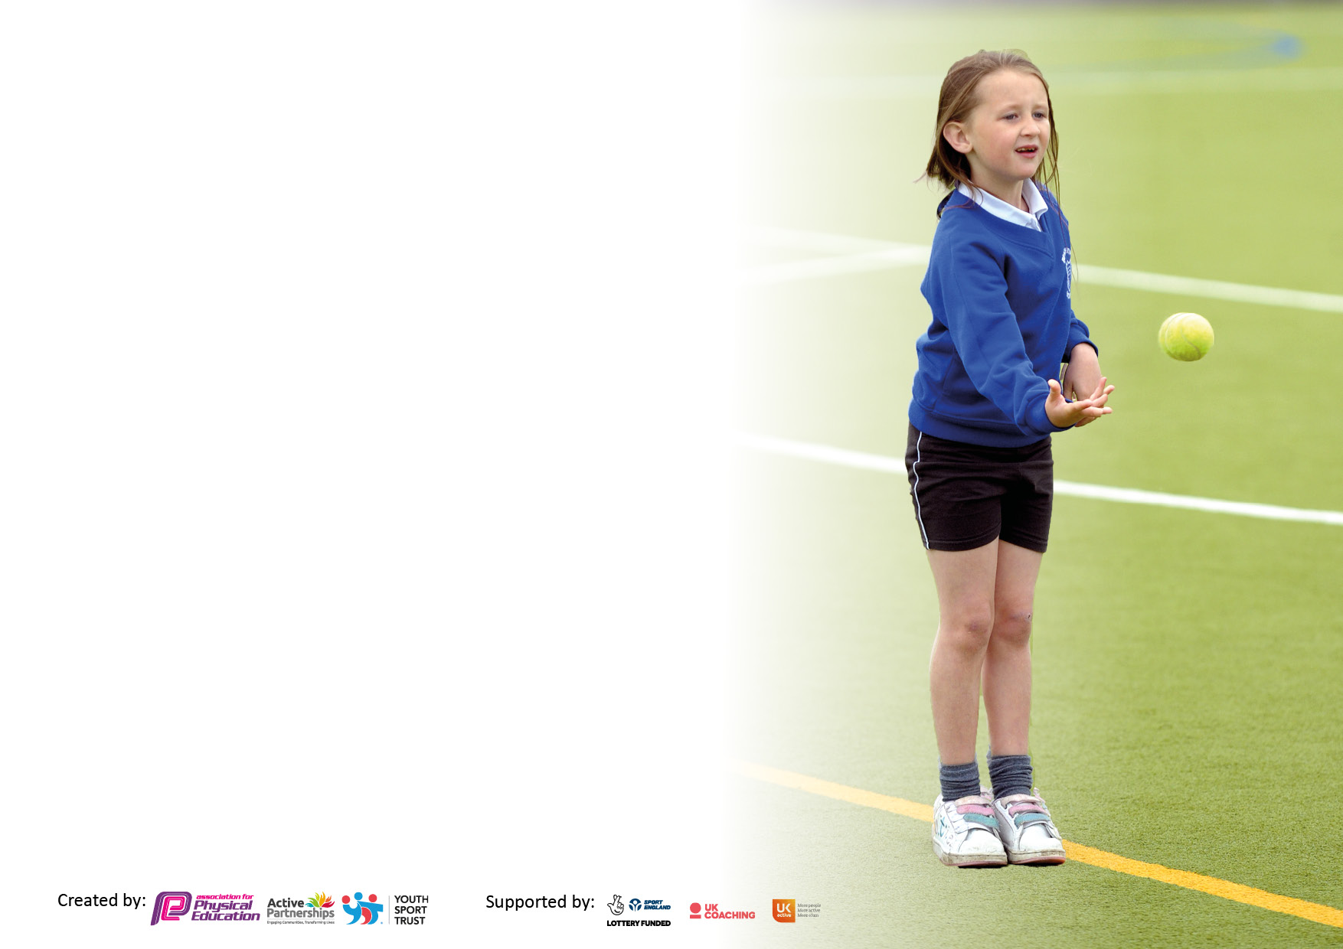

It is important that your grant is used effectively and based on school need. The Education Inspection Framework makes clear there will be a focus on ‘whether leaders and those responsible for governors all understand their respective roles and perform these in a way that enhances the effectiveness of the school’.

Under the Quality of Education Ofsted inspectors consider:
Intent - Curriculum design, coverage and appropriateness
Implementation - Curriculum delivery, Teaching (pedagogy) and Assessment
Impact - Attainment and progress

To assist schools with common transferable language this template has been developed to utilise the same three headings which should make your plans easily transferable between working documents.

Schools must use the funding to make additional and sustainable improvements to the quality of Physical Education, School Sport and Physical Activity (PESSPA) they offer. This means that you should use the Primary PE and sport premium to:

- Develop or add to the PESSPA activities that your school already offer
- Build capacity and capability within the school to ensure that improvements made now will benefit pupils joining the school in future years
- The Primary PE and sport premium should not be used to fund capital spend projects; the school’s budget should fund these.

Pleasevisitgov.ukfortherevisedDfEguidanceincludingthe5keyindicatorsacrosswhichschoolsshoulddemonstrate animprovement.Thisdocumentwillhelpyoutoreviewyourprovisionandtoreportyourspend.DfEencouragesschools to use this template as an effective way of meeting the reporting requirements of the Primary PE and sport premium.

We recommend you start by reflecting on the impact of current provision and reviewing the previous spend.

Schools are required to publish details of how they spend this funding, including any under-spend from 2019/2020, as well as on the impact it has on pupils’ PE and sport participation and attainment. All funding must be spent by 31st July 2022.

We recommend regularly updating the table and publishing it on your website throughout the year. This evidences your ongoing self-evaluation of how you are using the funding to secure maximum, sustainable impact. Final copy must be posted on your website by the end of the academic year and no later than the 31st July 2021. To see an example of how to complete the table please click HERE.
Created by: Supported by:

Details with regard to funding
Please complete the table below.

Total amount carried over from 2019/20 | £447
Total amount allocated for 2020/21 | £16810
How much (if any) do you intend to carry over from this total fund into 2021/22? | £266
Total amount allocated for 2021/22 | £16710
Total amount of funding for 2021/22. To be spent and reported on by 31st July 2022. | £7229
Swimming Data
Please report on your Swimming Data below.

Meeting national curriculum requirements for swimming and water safety.

N.B. Complete this section to your best ability. For example you might have practised safe self-rescue techniques on dry land which you can then transfer to the pool when school swimming restarts.
Due to exceptional circumstances priority should be given to ensuring that pupils can perform safe self rescue even if they do not fully meet the first two requirements of the NC programme of study
What percentage of your current Year 6 cohort swim competently, confidently and proficiently over a distance of at least 25 metres?  N.B. Even though your pupils may swim in another year please report on their attainment on leaving primary school at the end of the summer term 2021.  Please see note above | 60%
What percentage of your current Year 6 cohort use a range of strokes effectively [for example, front crawl, backstroke and breaststroke]?  Please see note above | 66%
What percentage of your current Year 6 cohort perform safe self-rescue in different water-based situations? | 60%
Schools can choose to use the Primary PE and sport premium to provide additional provision for swimming but this must be for activity over and above the national curriculum requirements. Have you used it in this way? | Yes/No

Action Plan and Budget Tracking
Capture your intended annual spend against the 5 key indicators. Clarify the success criteria and evidence of impact that you intend to measure to evaluate for pupils today and for the future.

Academic Year: 2020/21 | Total fund allocated: | Date Updated:
Key indicator 1: The engagement of all pupils in regular physical activity – Chief Medical Officers guidelines recommend that primary school pupils undertake at least 30 minutes of physical activity a day in school |  |  |  | Percentage of total allocation:
 |  |  |  | %
Intent | Implementation |  | Impact | Next Steps
To have more children, more active, more of the time.  This will have a positive impact on pupils’ academic achievements, mental wellbeing, their self-esteem and overall fitness. | To continue to offer a range of competitive sporting opportunities to a range of children.  Making links with local clubs to encourage participation outside of school.  Buy in to Carres Outreach to have ASCO one day per week to support children and teachers with high quality planning and implementation of PE.  Offer after-school clubs to meet the needs of pupil premium children. | Funding allocated:£2000  Carre’s package | Improved concentration in both active lessons and curriculum/classroom lessons.  Children have taken part in at least one of the activities offered by Carre’s Outreach | ASCo to use fitness profile data to support lesson planning next year to develop a more bespoke curriculum for different abilities.
Develop an assessment procedure that can be used to assess all children’s core skills. |  | £ 500  Staff release time
Key indicator 2: The profile of PESSPA being raised across the school as a tool for whole school improvement |  |  |  | Percentage of total allocation:
 |  |  |  | %
Intent | Implementation |  | Impact
Children will feel a sense of pride in representing our school within the local community. Their engagement in school life will be more positive as a result of their participation in sport/extra-curricular activities.  The children will have genuine interest in being active. | Visiting coaches and staff will help us to achieve the following:  All children will practice their Leadership Skills and utilise the wall charts to showcase their practice.  The school ClassDojo feed will be used to communicate School Sport and Physical Activities. | Funding allocated:£2000  All included in the Outreach package | Throughout the year regular updates have been posted and advertised on twitter about day to day school life and events.  Children have attended several inter school events this academic year. Children have been rewarded with intrinsic values and won several local school events. | Continue to work collaboratively with the School Sport Partnership in order to provide activities for children to attend. This will enable us to embed a participation culture and offer ensure inclusivity.

Key indicator 3: Increased confidence, knowledge and skills of all staff in teaching PE and sport |  |  |  | Percentage of total allocation:
 |  |  |  | %
Intent | Implementation |  | Impact
Your school focus should be clear | Make sure your actions to | Funding | Evidence of impact: what do | Sustainability and suggested
what you want the pupils to know | achieve are linked to your | allocated: | pupils now know and what | next steps:
and be able to do and about | intentions: |  | can they now do? What has
what they need to learn and to |  |  | changed?:
consolidate through practice:
Working with Carre’s, we will ensure our Teaching staff receive some PE or Sport CPD this year.  We will also support our Teaching Assistants to feel more confident in supporting our students with Physical Activity, PE and School Sport. | School staff will work with visiting teachers and coaches in order to increase the quality and range of their PE delivery.  Continue to use visiting experts (Carre’s Outreach, Chance to Shine Cricket, Dance, etc) to support the delivery of our PE and extra-curricular activities. | £ Inc in Outreach buy-in  Included  £5500 forest school  £300 Golf  £1670 resources | Termly PE Forums hosted by Matthew Strange have supported Mr Witham to hear good practice from other schools and to access resources and toolkits to support our development.  Teachers feel more confident in planning, teaching and assessing PE in schools. | Continue with Carre’s Outreach.  Training needs analysis for the staff – where do we need to improve our PE teaching skills?  Continue to develop the skills and confidence of the teaching staff.  PE lead to ensure continuity of PE across the school and in line with the national curriculum.  Look into support for EYFS so it compliments the rest of the school’s curriculum.
Key indicator 4: Broader experience of a range of sports and activities offered to all pupils |  |  |  | Percentage of total allocation:
Intent | Implementation |  | Impact
Your school focus should be clear | Make sure your actions to | Funding | Evidence of impact: what do | Sustainability and suggested
what you want the pupils to know | achieve are linked to your | allocated: | pupils now know and what | next steps:
and be able to do and about | intentions: |  | can they now do? What has
what they need to learn and to |  |  | changed?:
consolidate through practice:
School will use the funding to increase the number of opportunities available to our children both within and beyond the school day. | New sports and activities to be introduced throughout the school such as Dodgeball, Lacrosse and health related fitness.  Continue to target and sign post children to activities to fit their needs. | Inc with Carre’s buy-in | Attendance of 50%+ children on sports sessions offered.  Direct links from school to Park-Run, Sleaford Striders, Tae-Kwan Do and rugby. | Focus on SEND events.

Key indicator 5: Increased participation in competitive sport |  |  |  | Percentage of total allocation:
 |  |  |  | %
Intent | Implementation |  | Impact
Your school focus should be clear | Make sure your actions to | Funding | Evidence of impact: what do | Sustainability and suggested
what you want the pupils to know | achieve are linked to your | allocated: | pupils now know and what | next steps:
and be able to do and about | intentions: |  | can they now do? What has
what they need to learn and to |  |  | changed?:
consolidate through practice:
Children to experience competitions and festivals with/against other local schools.  All children to learn the values associated with competition via termly inter-school activities. | School to be a key part of the School Sport Partnership programme.  Increase opportunities for children to compete in community sports events e.g. Sleaford rugby Club, Sleaford Parkrun .  Maintain membership of Outreach programme.  Sign-post children to local clubs. | £6000  Staff cover and transport | Sleaford CCC  Sleaford rugby Club  Termly intra-sport competitions completed including athletics, cricket, and multi-sports. | Keep attending events with Carre’s Outreach.  Still have ASCo in to deliver lessons

Signed off by
Head Teacher: | Emma Hunt
Date: | July 2022
Subject Leader: | Ian Witham
Date: | July 2022
Governor: | Matt Timings
Date: | July 2022

