Forces of Nature

Summer Term 2025 | English  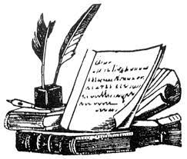  In English, we will be improving our grammar, language and ability to write for different purposes through our topic. Some of the exciting writing opportunities this term includes looking at narrative poetry (such as ‘The Highway Man’), an author study around Michael Morpurgo and explanation texts. All of these genres will not only extend children’s writing skills but will also link nicely with our new topic ‘Forces of Nature.’    Reading for pleasure and enjoyment will continue to lie at the heart of our English curriculum. Children will be involved in guided reading, using a diverse range of texts. They will take part in group discussions and will be encouraged to share their own views and reading interests. Through discussion and questioning, comprehension skills will be developed, enabling children to increase understanding and appreciation of literature. Children are actively encouraged to continue reading at home and please feel free to refer to our year 5 and 6 book lists for our recommended reads. Our class book this term is ‘Running Wild’ an exciting jungle tale.  Opportunities within all areas of the curriculum will be made available for children to develop their spoken language through discussion, drama and presentations.
More about our topic…
The Summer term topic for year 4, 5 and 6 will be a geography focus named ‘Forces of Nature.’ This topic will look at a range of natural disasters and deepen children’s understanding of the Earth and nature around us.
Throughout our geography lessons, we will be learning about tectonic plates, the Earth’s crust and a range of natural disasters such as tsunamis, volcanoes and earthquakes! Pupils will begin to extend their knowledge on how humans impact the Earth and will continue to use atlases and globes to locate a range of countries within a map or globe.
This first half term, our Art lessons will also focus on our topic as we will be looking at Hokusai’s ‘The Great Wave’. In DT, we will be looking at what it looks like to eat a balanced diet and creating our own food.
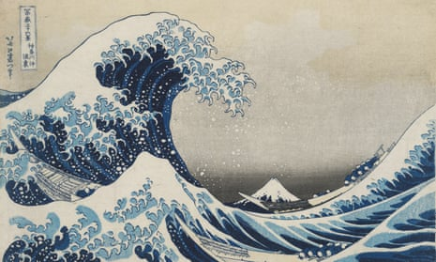

Make sure you continue to keep an eye on our web page to see some pictures of our learning!

Maths
Maths will be taught as an individual subject and will continue to adhere to the curriculum objectives. Teaching will enable children to become fluent in arithmetic as well as being able to reason and problem solve. Maths lessons will cover all aspects including, understanding number, using all four operations, measurement, geometry and statistics. Pupils will be extended at every opportunity to ensure their potential as mathematicians is achieved.
Take home task to support work in school
To prepare for our new topic, it would be brilliant if the children could research anything about natural disasters, such as tsunamis, volcanoes and earthquakes. This can be about anything that interests you! Present your findings through a medium of your choice, whether it be a picture, a piece of writing, or a model would be especially good! Please be ready to share your findings with the class.

