Goodnight Mr Tom

Spring Term 2025 | English  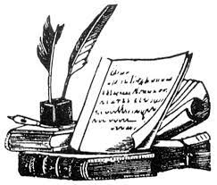  In English, we will be improving our grammar, language and ability to write for different purposes through our topic. Some of the exciting writing opportunities this term include: looking at war poetry, journalistic writing and stories with flashbacks. All of these genres will not only extend children’s writing skills, but will also link nicely with our new topic.  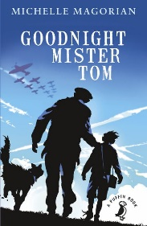  Reading for pleasure and enjoyment will lie at the heart of our English curriculum. Children will be involved in guided reading, using a wide range of texts, linked to topic. They will take part in group discussions and will be encouraged to share their own views and reading interests. Through discussion and questioning comprehension skills will be developed, enabling children to increase understanding and appreciation of literature. Children are actively encouraged to continue reading at home and we can help children with book recommendations that will expand their knowledge of the topic.  Opportunities within all areas of the curriculum will be made available for children to develop their spoken language through discussion, drama and presentations.
More about our topic…
To start off Spring term in 2025, year 4, 5 and 6’s brand new topic will be a history focus labelled ‘Goodnight Mr Tom.’ This will include studying the famous book by Michelle Margorian as well as looking in depth at World War II.
Throughout our history lessons we will be learning about how the war began, what life was like as an evacuee and life on the home front. Through cross-curricular learning we will partake in some exciting activities, and we are looking forward to this new adventure!
Pupils will extend their historical knowledge and be able to place important events on a timeline, study information from a variety of sources and ask a range of questions about the world’s past.
As previously mentioned, our key text will be ‘Goodnight Mr Tom’ by Michelle Margorian which is an emotional class book which we are excited to share with the children.

Make sure you continue to keep an eye on our web page to see some pictures of our learning!

Maths
Maths will be taught as an individual subject and will continue to adhere to the curriculum objectives. Teaching will enable children to become fluent in arithmetic as well as being able to reason and problem solve. Maths lessons will cover all aspects including, understanding number, using all four operations, measurement, geometry and statistics. Pupils will be extended at every opportunity to ensure their potential as mathematicians is achieved. Next term we will start by focussing on fractions, decimals and percentages.

